Enter Exit System (BCG Shared Assets) with Realistic Car Controller V3.4

# Importing Packages

First, you will need to import latest **BCG Shared Assets** to your project. It can be found in “**For BCG Shared Assets**“ folder.

Two new scenes (**FPS / TPS**) will be added in “**Scenes**” folder. These scenes have sample FPS / TPS character controllers.

You can edit some settings from (**Tools 🡪 BCG 🡪 Shared Assets 🡪 Edit Settings**).

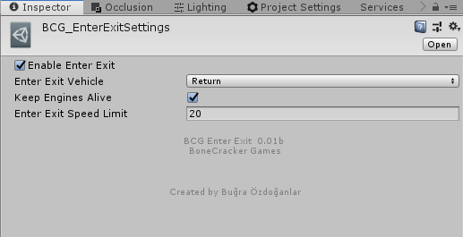

# How does it work?

FPS and TPS scenes have “**_BCGEnterExitManager**” gameobject with script attached to it. It will be created automatically if your scene has any vehicle or character with enter / exit script. This manager script is enabling / disabling character controller on enter / exit. And enabling / disabling controllable state of the vehicle with RCC camera.

Each vehicle must have “**BCG_EnterExitVehicle**” script attached. And character controller must have “**BCG_EnterExitFPS**” or “**BCG_EnterExitTPS**” script attached. You can simply add it from **Tools 🡪 BCG 🡪 Shared Assets 🡪 Enter-Exit 🡪 Add**…

